1. Software Re-Engineering (SRE)
Software Re-Engineering means improving existing software without changing what it already does.
👉 Goal:
- Make old software easier to understand
- Improve structure, quality, and maintainability
- Reduce errors and complexity
- Extend software life

2. Source Code Re-Engineering Reference Model (SCORE/RM)
This model helps us understand how software is re-engineered step by step.
It has four main elements:
- Function
- Documentation
- Repository Database
- Metrication

3. Elements of SCORE/RM

1️⃣ Function Element
This is the core process of re-engineering.
It is divided into 8 layers.
These layers help to:
- Remove duplicate code
- Improve control flow
- Understand requirements
- Rebuild software using good practices

2️⃣ Documentation Element
Documentation contains:
- Old software details
- New software details
- Specifications and constraints
- Design and implementation info
👉 Purpose:
- Helps developers understand what changed and why

3️⃣ Repository Database
This is like a central storage.
It stores:
- Old source code
- New source code
- Documentation
- Metrics data
👉 Purpose:
- Keeps everything organized in one place

4️⃣ Metrication Element
Metrication means measuring software quality.
Metrics are checked:
- Before applying a layer
- After applying the same layer
- To see how much improvement re-engineering has made

4. Function Element – 8 Layers (Very Important)

🔹 Reverse Engineering Layers
(Used to understand existing software)

🔹 Forward Engineering Layers
(Used to rebuild or improve software)

5. Reverse Engineering Layers (Top 6 Layers)

1️⃣ Encapsulation
- Hides data inside a single unit
- Protects data from outside access
- Improves security and control
- parsing code into an intermediate language, and baseline test generation.
Example:
Only access data through functions, not directly.

🔸 Parser (Used in Encapsulation)
A parser:
- Breaks source code into smaller parts
- Makes code easier to analyze
- Helps convert code into another form

2️⃣ Transformation
- The control flow is change to make code structured
- Keeps functionality the same
- Makes code cleaner and more readable

3️⃣ Normalization
- Removes unnecessary or duplicate code
- Standardizes coding style
- Makes code consistent

4️⃣ Interpretation
- Adding logical comments and eliminating global variables.
- Understands what the code is doing
- Converts low-level code into meaningful logic

5️⃣ Abstraction
- Method of hides unnecessary details
- Focuses only on important parts
Example:
Driving a car → you don’t need to know engine details.
Also includes:
- Understanding coupling (connection between modules)
- Understanding cohesion (internal strength of a module)

6️⃣ Causation
- Specifying user services, constraints, and modifying requirements for the new version.

6. Forward Engineering Layers (Bottom 3 Layers)

7️⃣ Regeneration
- Rebuilds the software
- Uses modern practices
- Improves structure and performance

8️⃣ Certification
- Ensures rebuilt software meets quality standards.
- Confirms correct implementation.
- Validation and verification.

9️⃣ Conformance
- Testing phase
- Checks that:
  - New software performs all old functionalities
  - No feature is missing

lexical analysis
- It takes modified source code from language preprocessors that are written in the form of sentences.
- The lexical analyzer breaks these syntaxes into a series of tokens, by removing any whitespace or comments in the source code
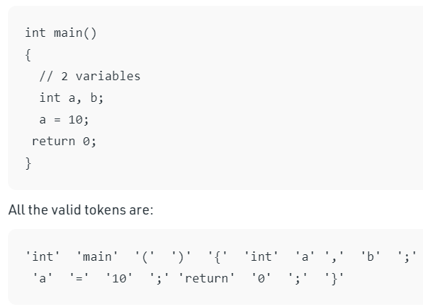

Syntactic analysis
- Syntactic analysis is performed by a parser.
- Parser is a compiler that is used to break the data into smaller elements coming from lexical analysis phase.
- A parser takes input in the form of sequence of tokens and produces output in the form of parse tree.

Control Flow Analysis (CFA)
Control flow analysis shows the order in which statements run in a program.

Types of Control Flow Analysis

1. Intraprocedural Analysis
- It shows the order in which statements are executed within a method.

Basic Block
- A basic block is a group of statements that:
  - Start together
  - End together
  - Have no jumps inside
2. Interprocedural Analysis
This is a global analysis that tracks flow across multiple functions. It builds a Call Graph to show which functions call each other.

Data Flow Analysis (DFA)
- Data flow analysis (DFA) concerns how values of defined variables flow through and are used in a program.
- Data flow analysis tracks how data (variables) move and change in a program.

What DFA Finds
- Use of undefined variables
- Unused code
- Variables used before assignment
- Code affected when a bug is fixed

1. What is a Legacy System?
A legacy system is an old software system that is still in use but is difficult to maintain, modify, or integrate with modern systems.

2. Characteristics of Legacy Systems
A legacy system usually has:
- Old programming languages (COBOL, FORTRAN, old C, old Java)
- Old hardware or operating systems
- Poor or no documentation
- Complex and tightly coupled code
- Few developers who understand it
- High maintenance cost

3. Factors That Make a System “Legacy”

1. Technical Factors
- Outdated programming language
- Old database
- Unsupported hardware/software
- No modular design

2. Business Factors
- Still critical for business operations
- Replacing it is expensive
- System contains valuable business rules

3. Human Factors
- Original developers have left
- Current team does not fully understand the system
- Lack of training

4. Documentation Factors
- No proper documentation
- Design decisions are unclear

4. Problems with Legacy Systems
- Difficult to add new features
- High maintenance cost
- Security risks
- Poor performance
- Hard to integrate with new systems
- Risk of system failure

5. Techniques / Strategies to Deal with Legacy Systems
This is very important for exams ⭐

1. Continue Maintenance (Do Nothing)
- Keep using the system as it is
- Fix bugs only
✅ Used when:
- System is stable
- Budget is low
❌ Problems:
- Technical debt increases

2. System Wrapping (Encapsulation)
- Keep the legacy system
- Add a wrapper layer (API/interface) around it
- New systems communicate through the wrapper
✅ Advantages:
- Low risk
- Faster solution
❌ Disadvantages:
- Core system still remains old

3. Re-engineering (Improving the Existing System)
- Modify the system internally
- Improve structure and readability
- Keep same functionality
Includes:
- Code refactoring
- Database restructuring
- Documentation update
✅ Advantages:
- Less risky than rebuilding
- Improves maintainability

4. Migration
- Move system to:
  - New platform
  - New database
  - New programming language
Example:
- From on-premise → cloud
- From old database → modern database

5. Replacement (Redevelopment)
- Completely discard old system
- Build a new system from scratch
✅ Advantages:
- Modern, efficient system
❌ Disadvantages:
- Very expensive
- High risk
- Time-consuming

6. Comparison Summary (Exam Friendly)
Strategy | Risk | Cost | Time
Do nothing | Low | Low | Short
Wrapping | Low | Medium | Short
Re-engineering | Medium | Medium | Medium
Migration | Medium | High | Long
Replacement | High | Very High | Very Long

Requirements management ensuring that requirements are:
Satisfied – Did we capture all the business needs
Feasible – Can we do this within budget and resource constraints
Justified – Do we need to be doing this
Consistent – Are we doing this right
Testable – Are we doing the right thing

Traceability Definition
The capability to identify and record the origin of every requirement, including how it was developed (backward traceability), its allocation (forward traceability), and its relationships to other requirements.
Traceability is the act of connecting a requirement to, from or across any other artifact produced during development, including:
Business need – Connects to system requirements
System Requirement – Connects to business needs, to design modules and test cases
Design module – Connects to system requirements and to test cases
Test case – Connects to system requirements and to design modules.
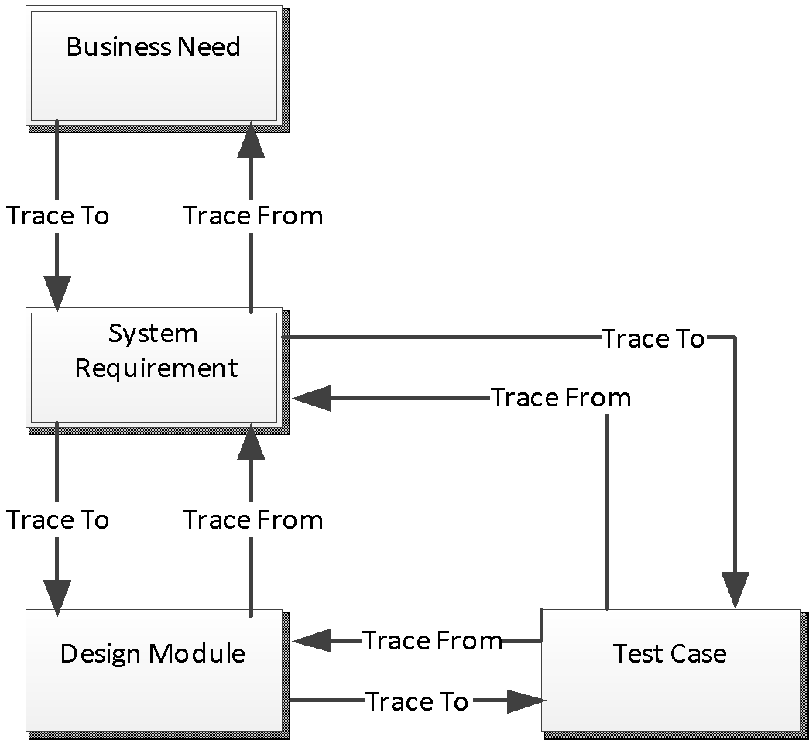

Why is Traceability Important?
Traceability helps to:
- Ensure all requirements are implemented
- Understand impact of changes
- Reduce risk during modification
- Improve system documentation
- Avoid missing or extra features
- Improve quality and reliability
- Support maintenance

Types of Traceability

1. Forward Traceability
- Track from requirements → design → code → test
- Ensures every requirement is implemented
✅ Example:
Requirement → Module → Test case

2. Backward (Reverse) Traceability
- Track from code/test → requirement
- Ensures no extra or unnecessary features exist
✅ Example:
Code module → Related requirement

Traceability Matrix (RTM)
A Requirements Traceability Matrix (RTM) is a table that shows the relationship between:
- Requirements
- Design components
- Code modules
- Test cases

Simple RTM Example:
Requirement | Design | Code Module | Test Case
Login | UI Design | Auth.java | TC-01
Payment | Payment Design | PayService.java | TC-02

